2. Hive + Parquet

in S3.

**Database:** <user_id>_airlines

**Database:** <user_id>_airlines_raw

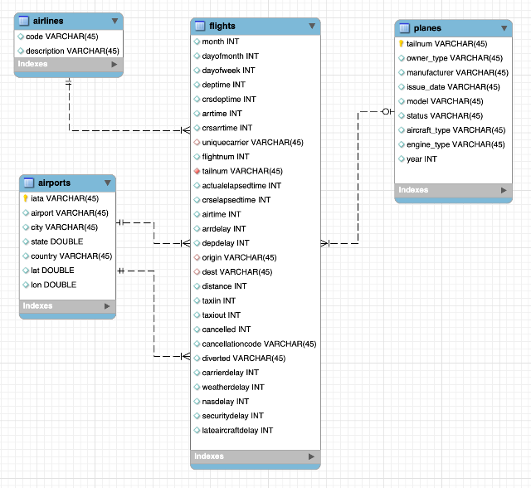

5b. In-Place migration

in S3.

6. Iceberg Table (Parquet + Partition) + Data Load

in S3.

4. Hive ACID

in S3.

3. Hive + ORC

in S3.

5a. Iceberg Table + CTAS

in S3.

1. All tables stored as CSV files in S3.

in S3.